**REPUBLIC OF CAMEROON REPUBLIQUE DU CAMEROUN**

**Peace – Work – Fatherland**   **Paix – Travail – Paitrie**



**FACULTY OF ENGINEERING AND TECHNOLOGY**

**DEPARTMENT OF COMPUTER ENGINEERING**

**SPECIALIZATION: SOFTWARE ENGINEERING**

**COURSE TITLE: SOFTWARE QUALITY TOOLS AND TESTING**

**ASSESSMENT AND FEATURE REQUIREMENT FOR TELEMEDCINE APP:**

**MEDIK**

|  |  |  |
| --- | --- | --- |
|  | **NAMES** | **MATRICULE NUMBERS** |
| **1** | **QUINUEL TABOT NDIP-AGBOR** | **FE21A300** |
| **2** | **INDAH RICOBELLE MBAH** | **FE21A204** |
| **3** | **SIRRI THERESIA ANYE** | **FE21A306** |
| **4** | **TSAPZE ZAMBOU ROSELINE** | **FE21A328** |
| **5** | **ENOW MYKE-AUSTINE ETA** | **FE21A183** |
| **6** | **MOKFEMBAM FABRICE KONGNYUY** | **FE21A240** |
| **7** | **MONDOA ROBERT** | **FE21A241** |
| **8** | **TAKEM JIM** | **FE21A309** |
| **9** | **KENFACK SAMEZA** | **FE21A213** |
| **10** | **FOLETIA AJONGAKUI SYNCLAIR** | **FE21A190** |

**COURSE INSTRUCTOR: DR. TSAGUE ALINE**

**TABLE OF CONTENTS**

**I.** **INTRODUCTION** 3

**II.** **PROJECT DETAILS, REQUIREMENT DESCRIPTION AND STANDARDS ANALYSIS** 4

1) **FUNCTIONAL REQUIREMENTS** 4

2) **NON-FUNCTIONAL REQUIREMENTS** 5

3) **INTERNATIONAL QUALITY STANDARDS FOR TELEMEDICINE APPS** 6

III. ANALYSIS AND RESEARCH ILLUSTRATION FOR MEDIK 7

1) **OVERVIEW** 7

2) **ANALYSIS** 7

3) **RESEARCH** 9

4) **ILLUSTRATION** 9

IV DESIGN……………………………………………………………

IV. 5) **Benefits Of MEDIK To The Cameroonian Population** …………

**CONCLUSION**…………………………………………………………………………………………………………………………. 12

**V.REFERENCE**……………………………………………………………… 13

# I. INTRODUCTION

Telemedicine applications, also known as telehealth apps, have emerged as transformative tools in the healthcare landscape. These mobile applications enable individuals to access healthcare services remotely, bridging geographical distances and overcoming mobility challenges. By leveraging the power of smartphones and other digital devices, telemedicine applications are revolutionizing the way healthcare is delivered and consumed.

MEDIK, a leading telemedicine application, stands at the forefront of this transformative movement. MEDIK offers a comprehensive suite of services designed to provide convenient and accessible healthcare to individuals from all walks of life. The application's core functionalities include:

* **Real-time video and audio consultations:** MEDIK empowers patients to connect with licensed healthcare providers via secure video or audio calls, enabling face-to-face interactions for diagnosis, treatment planning, and follow-ups.
* **Secure messaging:** MEDIK facilitates seamless communication between patients and healthcare providers through a secure messaging platform, allowing for asynchronous exchanges of information, questions, and concerns.
* **Online prescription generation:** MEDIK streamlines the prescription process by allowing healthcare providers to electronically generate and send prescriptions directly to pharmacies, eliminating the need for paper prescriptions.
* **Pharmacy services:** MEDIK integrates with partner pharmacies, enabling patients to conveniently order and receive medications directly through the application.
* **Appointment scheduling:** MEDIK simplifies appointment scheduling, allowing patients to browse available time slots and book appointments with their preferred healthcare providers directly from the app.
* **Personalized health notifications:** MEDIK goes beyond consultations and prescriptions by providing personalized health notifications based on a patient's medical history, lab test results, and diagnoses. These notifications may include health tips, medication reminders, and follow-up appointment prompts.

MEDIK's comprehensive suite of features caters to a wide range of healthcare needs, from routine checkups and prescription renewals to chronic disease management and mental health counseling. The application's user-friendly interface and secure communication protocols make it accessible to individuals of all ages and technical proficiency.

In a world where healthcare accessibility is often hindered by geographical barriers, mobility limitations, and time constraints, telemedicine applications like MEDIK are paving the way for a more equitable and inclusive healthcare system. By bridging the gap between patients and healthcare providers, these applications are empowering individuals to take control of their health and well-being.

# II. PROJECT DETAILS, REQUIREMENT DESCRIPTION AND STANDARDS ANALYSIS

#### 1) FUNCTIONAL REQUIREMENTS:

Functional Requirements describe what a system must do. They specify the functions and features that the system must provide to meet the user's needs.

➢ **User Authentication and Security:**

* Secured user registration and login using multiple authentication factors, including username, password, and biometric fingerprint.
* Enforced password complexity and change requirements.
* Secure storage and encryption of user credentials and personal data.
* Implementation of role-based access control (RBAC) to restrict access to sensitive information.
* Regular security audits and vulnerability assessments.

➢ **Patient-Healthcare Provider Communication and Consultation:**

* Real-time video, audio, and messaging communication between patients and healthcare providers.
* Scheduling and management of virtual consultations.
* Secure file sharing for exchanging medical records, images, and other relevant documents.
* Integration with third-party communication platforms.
* Real-time translation services for multilingual communication.

➢ **Payment Processing and Transactions**

* Integration with secure payment gateways for online transactions.
* Support for multiple payment methods (credit cards, debit cards, mobile wallets).
* Generation of detailed transaction receipts for consultations, diagnosis, and medication purchases.
* Secure storage and processing of payment information.
* Compliance with relevant payment industry standards (PCI DSS).

➢ **Appointment Scheduling and Management**

* Real-time scheduling and management of appointments for both patients and healthcare providers.
* Availability of appointment slots based on healthcare providers' schedules.
* Synchronization with healthcare providers' calendars and scheduling systems.
* Automated appointment reminders and notifications.
* Waitlist management for oversubscribed appointments.
* Integration with patient calendars for seamless scheduling.

➢ **Medical Records Management**

* Secure and centralized storage of patient medical records, including test results, prescriptions, and other relevant health information.
* Patient-controlled access to their medical records.
* Sharing of medical records with healthcare providers with patient consent.
* Data encryption and access logging for audit purposes.
* Compliance with relevant data privacy regulations (HIPAA, GDPR).
* Integration with electronic health record (EHR) systems for comprehensive patient data management.

➢ **Prescription Services**

* Electronic prescription (eRx) generation and management.
* Direct transmission of prescriptions to pharmacies.
* Patient consent management for sharing prescription information with pharmacies.
* Integration with pharmacy management systems.
* Medication affordability and delivery options, including generic drug recommendations and pharmacy discounts.

### 2) NON-FUNCTIONAL REQUIREMENTS:

### Security and Privacy:

* MEDIK adheres to strict security standards (e.g., HIPAA compliance) to ensure the confidentiality, integrity, and privacy of patient data.
* MEDIK provides assurance and sustainable database to store and duplicate data of patients for medical and research purposes.
* **Usability and User Experience:**
* MEDIK has an intuitive and user-friendly interface, making it easy for users to navigate, schedule appointments, communicate, and access their information.
* **Performance and Scalability:**
* MEDIK is capable of handling concurrent users and providing a smooth and responsive experience, even during peak usage times.
* **Reliability and Availability:**
* MEDIK is reliable, ensuring consistent availability and minimal downtime to avoid disruptions in accessing healthcare services.
* **Compatibility and Integrations:**
* The app should be compatible with various devices, operating systems (e.g., iOS, Android), and browsers to cater to a wide range of users.
* It should also support integrations with other healthcare systems, such as electronic health records (EHR) or pharmacy systems.
* **Accessibility:**
* MEDIK will comply with accessibility standards to ensure that individuals with disabilities can access and use the app effectively.
* **Regulatory Compliance:**
* The app should adhere to relevant regulations and guidelines, such as HIPAA, GDPR, and local telemedicine practice guidelines.
* **Internationalization:**
* MEDIK is multilingual and can be used across 50+ international languages.

### 

### 3) INTERNATIONAL QUALITY STANDARDS FOR TELEMEDICINE APPS:

Internationally socially used standards include:

* **Health Insurance Portability and Accountability Act (HIPAA):** HIPAA sets the standards for protecting sensitive patient health information in the United States. If your telemedicine app serves users in the U.S., compliance with HIPAA regulations is crucial to safeguard patient privacy and security.

* **General Data Protection Regulation (GDPR):** GDPR is a comprehensive data protection regulation that applies to the European Union (EU) and European Economic Area (EEA). If your telemedicine app serves users in EU/EEA countries, compliance with GDPR is necessary to ensure the lawful and secure processing of personal data.

* **International Organization for Standardization (ISO) 27001:** ISO 27001 is an internationally recognized standard for information security management systems. Adhering to ISO 27001 guidelines helps ensure that your telemedicine app implements robust security controls, risk management processes, and data protection measures.

The professional descriptions of most commonly used international standards for telemedicine apps include:

* **Health Level 7 (HL7) :** HL7 is an international standard for the exchange of electronic health record (EHR) data. It is a comprehensive standard that covers a wide range of clinical and administrative data, including patient demographics, diagnoses, medications, allergies, and laboratory results. HL7 is widely used in telemedicine applications to exchange data between different healthcare systems.

* **Digital Imaging and Communications in Medicine (DICOM):** DICOM is an international standard for the exchange of medical images, such as X-rays, CT scans, and MRI scans. DICOM is widely used in telemedicine applications to transmit medical images from one location to another for consultation or diagnostic purposes.

* **Fast Healthcare Interoperability Resources (FHIR):** FHIR is a newer standard that is based on modern web technologies, such as JSON and HTTP. FHIR is designed to be more flexible and easier to implement than HL7, and it is gaining popularity in the telemedicine industry.

## III. ANALYSIS AND RESEARCH ILLUSTRATION FOR MEDIK

#### 1) OVERVIEW

Telemedicine is the use of telecommunications technology to provide healthcare services remotely. The telemedicine app, MEDIK, is out to provide patients with convenient and affordable access to healthcare services, especially for those in rural or underserved areas.

#### 2) ANALYSIS

MEDIK is a telemedicine app that provides patients with a variety of services, including:

* Video, audio and messages consultations with healthcare providers
* Prescription management
* Medical records management
* Secure communication
* Appointment scheduling
* Patient education materials
* Pharmacy services

MEDIK is a user-friendly app that is easy to navigate. The app is also secure and compliant with all applicable privacy regulations.

#### 3) RESEARCH

There is a growing body of research that supports the effectiveness of telemedicine apps. For example, a study published in the Journal of the American Medical Association found that telemedicine was as effective as in-person care for a variety of conditions, including chronic diseases and mental health conditions. And Fig 1. Below shows an illustration of MEDIK’s details

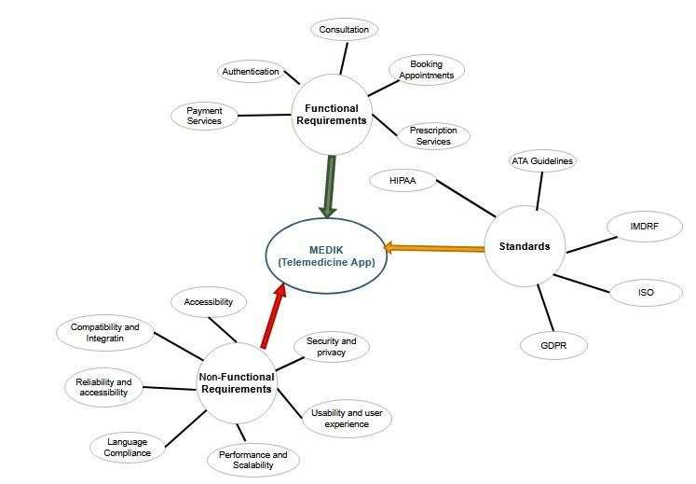

Figure 1

#### 4) ILLUSTRATION

Imagine a patient named Sarah who lives in a rural area. Sarah has a chronic disease that requires regular monitoring. In the past, Sarah had to drive for hours to see her doctor. However, now that she has MEDIK, she can schedule a video consultation with her doctor from the comfort of her own home.

**IV DESIGN (Software Requirements Analysis)**

The design process **clarifies the required features and overall vision of MEDIK**. The following designs where implemented;

* + 1. **SYSTEM DESIGN**

System design is the process of designing the elements of a system such as the architecture, modules, and components, the different interfaces of those components, and the data that goes through that system. This is done by implementing various UML diagrams.

* **Class Diagram**

**I**t shows the main classes of the system such as transactions, users, patients, appointments, doctors and more.

* **Activity Diagram**

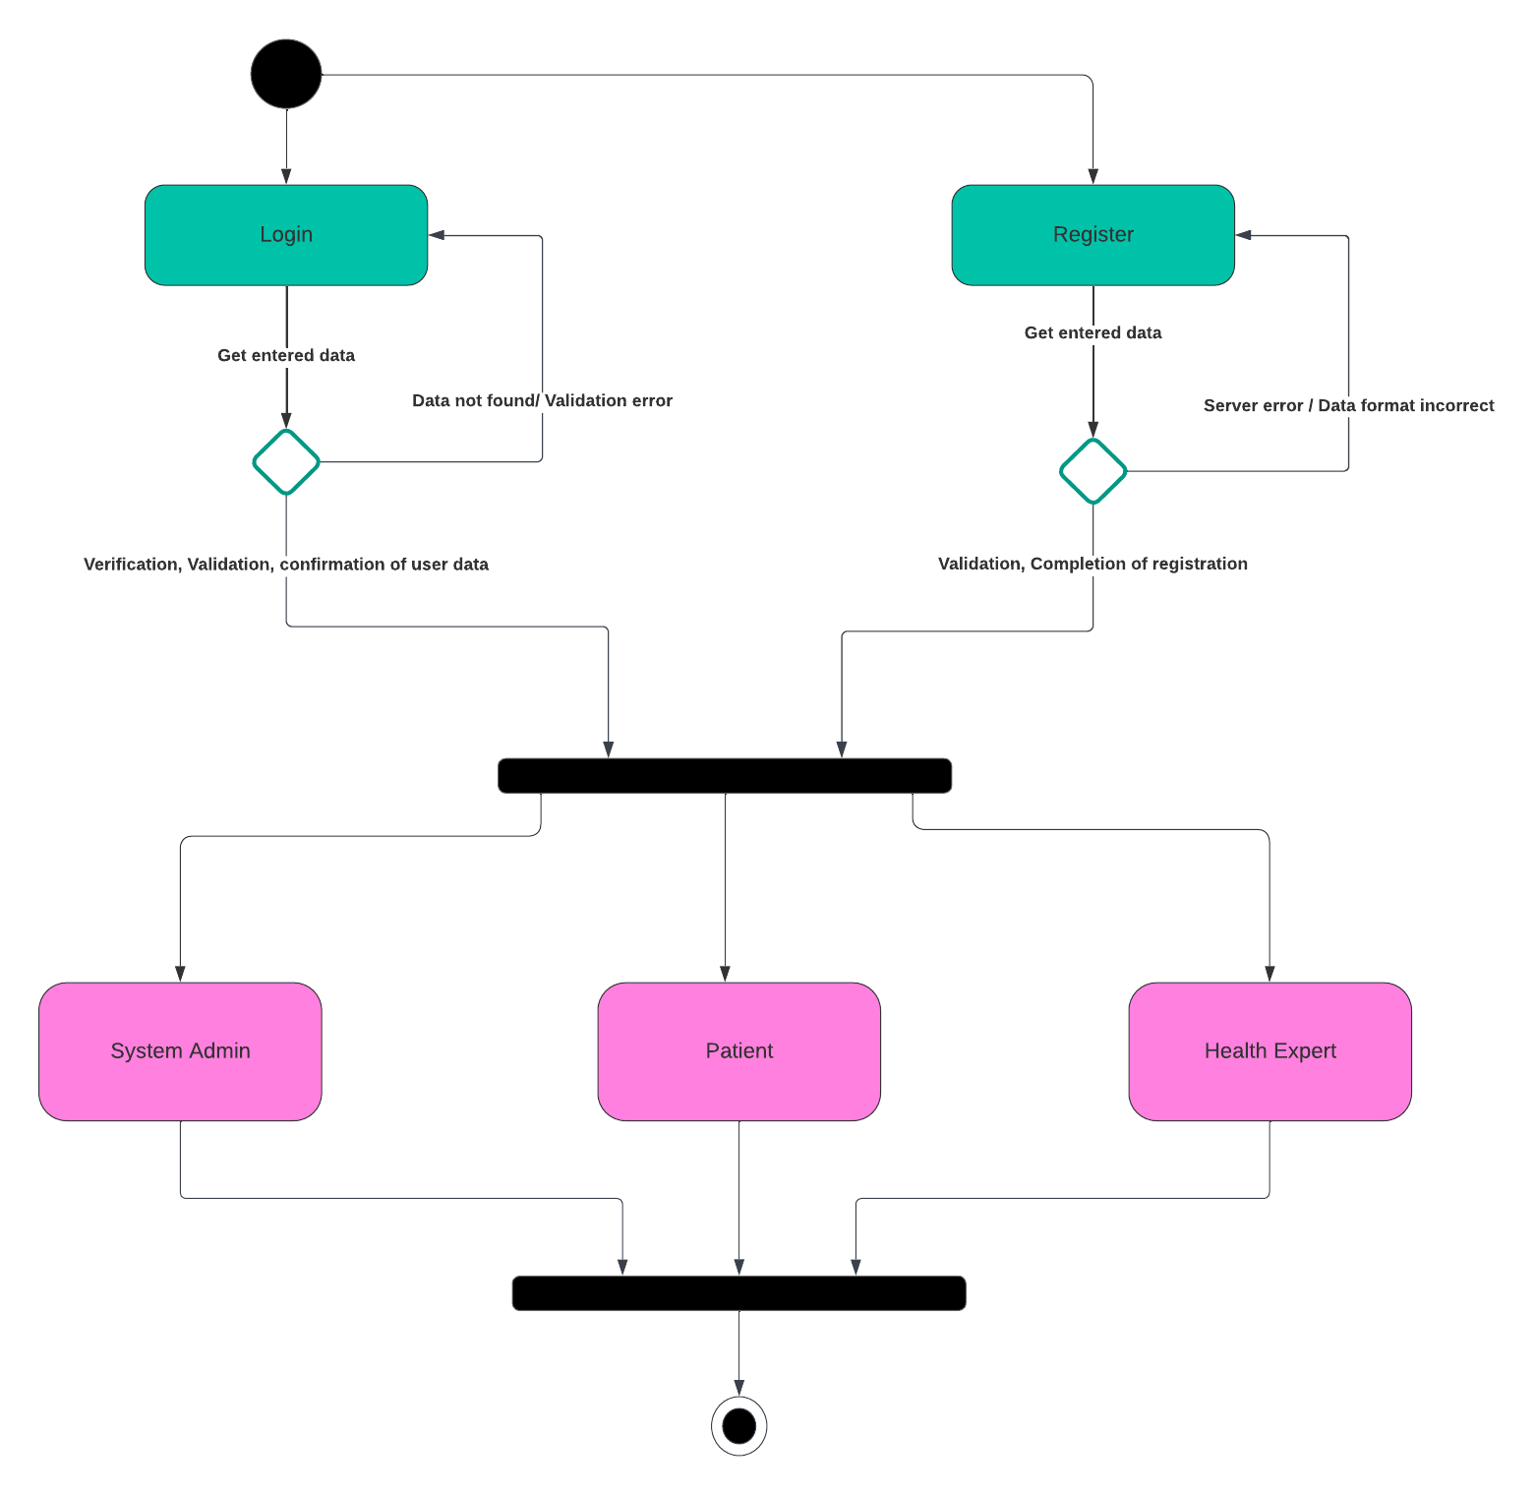

**Figure 3.0 Activity Diagram for login and registration**

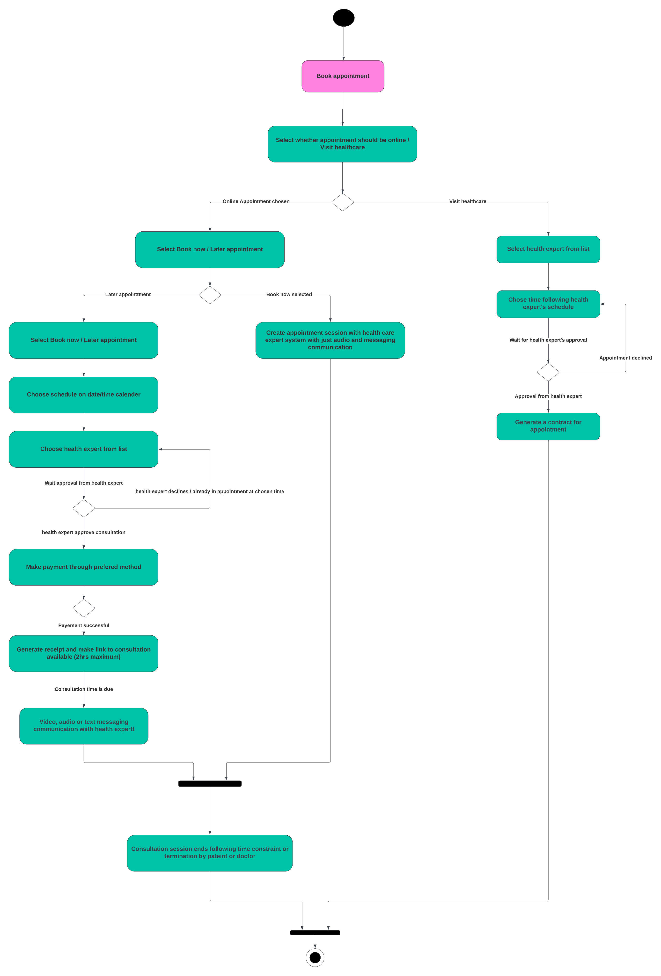

**Figure 3.1 Activity diagram for patient’s booking**

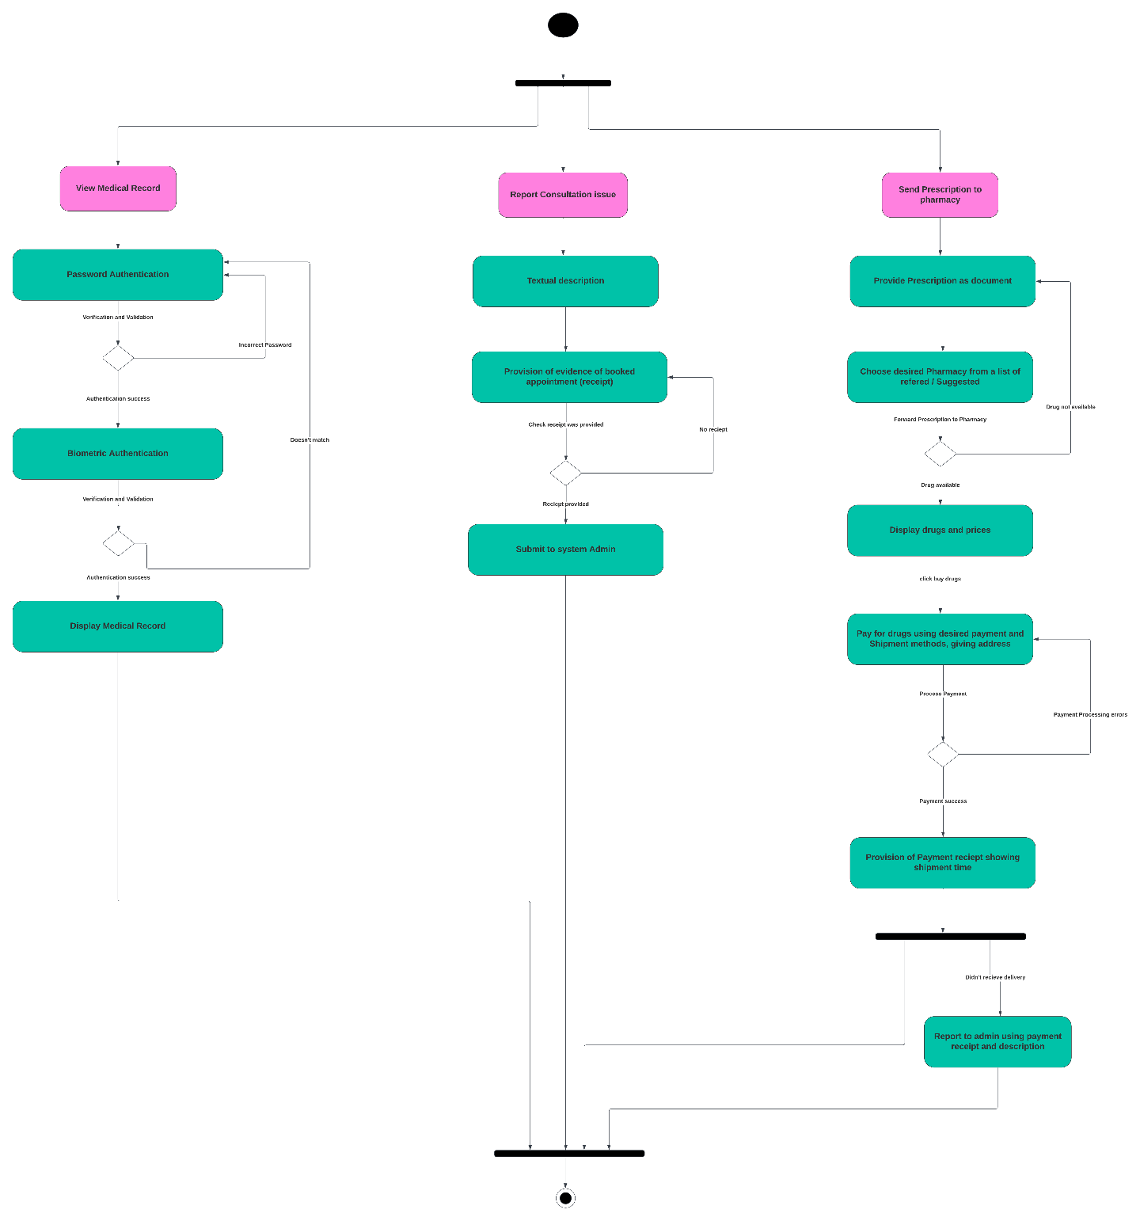

**Figure 3.2 Activity diagram for patient's appointment**

* **Use Case Diagram**

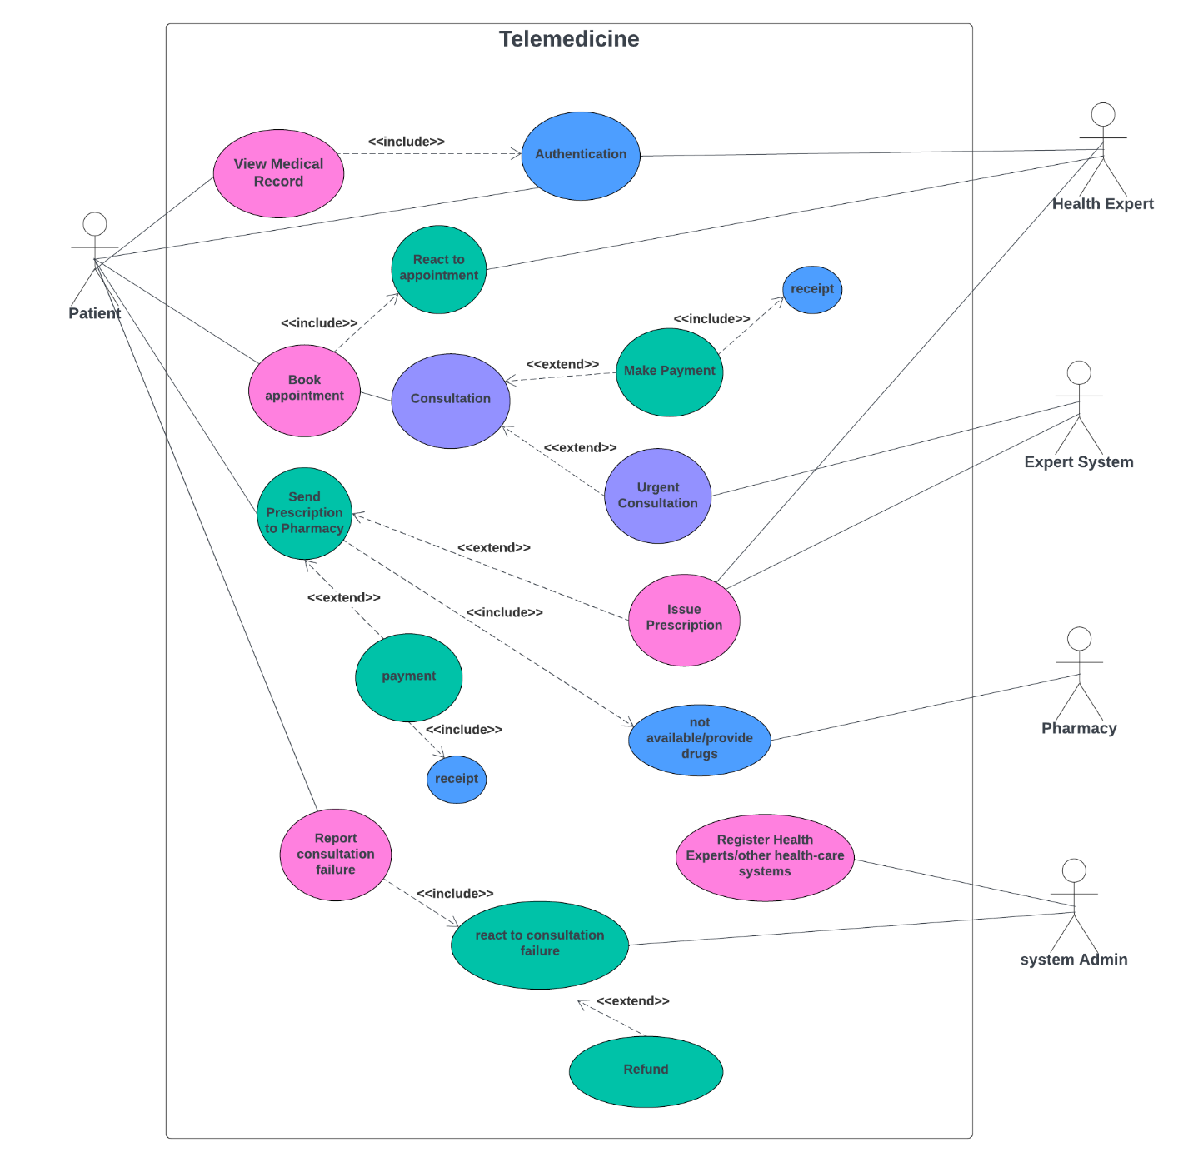

**Figure 4.0**

**2. UI DESIGN**

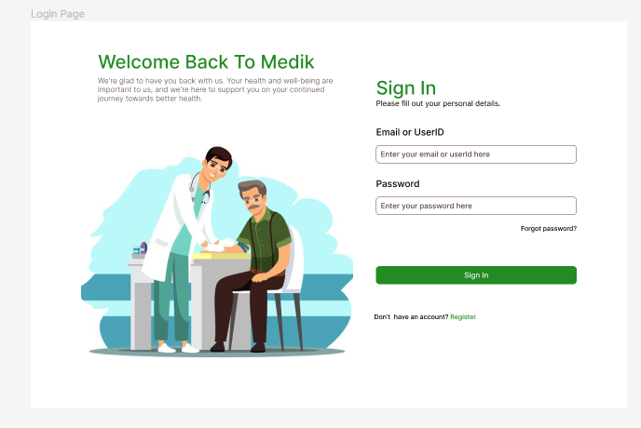

Figure 5.0

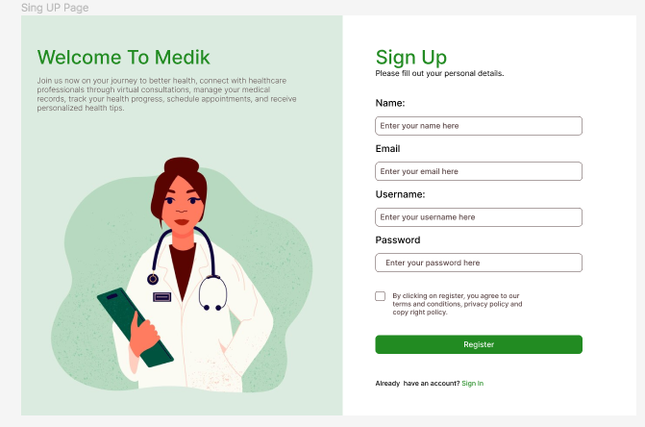

Figure 5.1

**3. DATABASE DESIGN**

The database has been developed using MySql workbench.

This database consists of seven tables that store the information as seen on the above ER diagram. Having this amount of tables, strengthens the security of the system such that the won’t be any interference with data, ensures data integrity and avoid conflicts.

**Software Quality Model for MEDIK Telemedicine App**

**Purpose**

The purpose of this software quality model is to define the quality attributes and requirements for the MEDIK telemedicine app. This model will be used to guide the development and testing of the app to ensure that it meets the needs of its users and stake holders. AdEQUATE and ISO/IEC 25010 where the models chosen for the quality development of our app.

The AdEQUATE Software Quality Evaluation Model is a quality in use model that focuses on assessing the quality of software from the user's perspective. It was developed in the 1990s and has been used to evaluate a wide range of software applications, including telemedicine apps. The model is based on the following four dimensions:

Adequacy: The software should meet the user's needs and expectations.

Usability: The software should be easy to learn, use, and understand.

Performance: The software should be responsive and efficient.

Reliability: The software should be free from defects and should be able to handle unexpected situations.

The AdEQUATE Model is a useful tool for evaluating the usability of telemedicine apps. It can help to identify areas where the app is difficult to use and can provide suggestions for improvement. The model is also relatively easy to apply, making it a good choice for organizations that are new to software quality assessment.

ISO/IEC 25010 Quality Models

The ISO/IEC 25010 Quality Models are a family of quality models that provide a comprehensive framework for assessing the quality of software systems. The models were developed by the International Organization for Standardization (ISO) and the International Electrotechnical Commission (IEC). The models are based on the following eight characteristics:

Functionality: The software should fulfill its specified requirements.

Reliability: The software should be free from defects and should be able to handle unexpected situations.

Usability: The software should be easy to learn, use, and understand.

Efficiency: The software should make optimal use of system resources.

Maintainability: The software should be easy to modify and maintain.

Portability: The software should be easy to transfer from one hardware or software environment to another.

Security: The software should protect user data from unauthorized access, use, disclosure, disruption, modification, or destruction.

Testability: The software should be designed in a way that makes it easy to test.

The ISO/IEC 25010 Quality Models are a valuable tool for assessing the overall quality of telemedicine apps. They can help to identify areas where the app is not meeting its requirements and can provide suggestions for improvement. The models are also a good choice for organizations that are looking to implement a quality management system for their software development process.

Comparison of the Two Models

The AdEQUATE Model and the ISO/IEC 25010 Quality Models are both useful tools for assessing the quality of telemedicine apps. However, they have different strengths and weaknesses. The AdEQUATE Model is particularly useful for evaluating usability, while the ISO/IEC 25010 Quality Models provide a more comprehensive framework for assessing software quality.

**SOFTWARE TESTING**

Software testing is the process of checking the quality, functionality, and performance of a software product before launching. To do software testing, testers either interact with the software manually or execute test scripts to find bugs and errors, ensuring that the software works as expected. Software testing is also done to see if business logic is fulfilled, or if there are any missing gaps in requirements that need immediate tackles.

Testing is categorized into two as seen below

**Testing Categories**

* 1. **Static Testing**

Static testing is an approach to testing the software application without executing the actual code. This is performed at the early stage of development to identify the issues in the project documents in multiple ways, namely reviews, walkthroughs, and inspections.

Static testing is analysing the project specifications at the initial stage of development. If defects are detected at the early stage cost of the testing is reduced. With static testing, we can identify ambiguities in project documentation, misunderstandings of requirements, or flaws in the requirement and design issues. Static testing is required to improve development productivity. Coding mistakes can be detected and rectified at the initial stage of development by static testing.

### Types of Static Testing

Static testing can be done mainly by manual and automated methods as described below.

* **Design Testing:** Design testing is the process of checking designs in terms of requirements and content.

Found below are the various types of design testing which will be implemented at the design stage of our development process.

* **UI testing:**
* **find differences between requirements and designs** – sometimes after reviewing requirements it can happen that the reviews don’t end up in the designs,  e.g. according to requirements, view X should contain the name and surname field, and the design includes the name and date of birth fields.
* **find typos in texts** – developers copy text from designs, and mistakes happen all the time. Detecting a typo at this stage means that you won’t have to correct it directly in the (semi) finished application.
* **find deficiencies in the requirements** – e.g. according to the designs, the view should contain five fields (because of reasons), and the description specified only three (because it didn’t take “the reasons” under consideration).
* **find deficiencies in designs** – it can happen the other way round too, when the design doesn’t contain all the elements described in the requirements, e.g. missing buttons.

#### Manual Methods of Static Testing

Detailed evaluation of project-specific documents done manually performed by different project members like architects, designers, managers, moderators, and reviewers.

Types of manual methods:

1. Inspections
2. Walkthroughs
3. Informal Reviews
4. Technical Review

* **Inspections**: These are the most formal way of static testing, a dedicated moderator initiates the process and conducts a complete formal review by scheduling a meeting. Proper documentation has been prepared before and after the meeting, and peer reviews will happen to understand the product. observations and issues are documented as issue logs and the moderator will do a follow-up and schedule meetings accordingly till the closure. The Author is responsible for resolving the identified defects and improving the quality. Reviewers are responsible for checking the documents and reviewing the defects during the inspection process. The manager will take care of the planning for the inspection process and ensures whether the goal has been met or not.
* **Informal Reviews:** These reviews are performed mainly as peer reviews, management participation is not mandatory. There is no need for any report generation after the meeting. Feedback from the team will be captured and implemented wherever necessary.
* **Technical Review**: A  formal way of review conducted by a trained moderator or by a technical expert. Potential defects can be identified by the document review by architects, designers, and users who focus on the content of the documentation. This is beneficial to understand the progress of the project. The major goal of this method is to focus on technical concept corrections and identifying alternatives if required, to improve the understanding of technical information among the team members.
* **Walkthrough:** This is not a formal process, usually the meeting is led by the author of the documentation, aiming for a common understanding of the proposed solutions and taking the feedback. It’s like a knowledge transfer and examining the content of the documentation with the participants. This is useful for high-level documents like requirement specifications.

#### Automation Method of Static Testing

The automation method of static testing is nothing but code analysis by some tools. Source code analysis or debugging is done by different tools, and by the developers. It is called static analysis.

* **Static Analysis:** Static analysis is the code analysis performed to understand the code structure and coding standards. It’s a debugging performed to examine the source code without executing the program. This is helpful for developers to ensure identifying programming errors, syntaxx errors, security issues and performance issues, and coding standard violations. Different tools like Pycharm, Checkstyle, and SourceMeter are available to analyse data flows and control flows in the source code in the targeted programming language. Some examples of these tools are mentioned here.

Types of automation methods or static analysis

* **Control flow analysis :** This is a static code analysis techniques used to check the control flow of the programming language and it is defined in control flow graph and verifies the functions or modules and subroutines to check the process flows.
* **Data flow analysis: T**his method used to verify the data structures and definitions of variables and their usage without executing the code.
* **Failure analysis :**This method is used to identify the causes of  design failures and condition failures**,** incorrect behaviour of the modules etc.
* **Interface analysis:** This method is used to analyze the different interfaces used the program model and to identify the integrations and  simulations.
  + 1. **Dynamic Testing**

Dynamic testing refers to analyzing code’s dynamic behavior in MEDIK. In this type of testing, input is given and gotten as per expectation through executing a test case. The test cases can be run manually or through an automation process, and the software code must be compiled and run for this.

The main purpose of dynamic testing is to validate the software and ensure it works properly without any faults after the installation.

### Types of Dynamic Testing

#### 1. Functional Testing

It checks the functionality of an application as per the requirement specifications. Each module needs to be tested by giving an input, assuming an output, verify the actual result with the expected one. Further, this testing divides into four types –

* Unit testing**:**It tests the code’s accuracy and validates every software module component. It determines that every component or unit can work independently.
* Integration testing**:**It integrates or combines each component and tests the data flow between them. It ensures that the components work together and interact well.
* **System Testing:**It makes to test the entire system. So it’s also known as end-to-end testing. Work through all the modules and check the features so that the product fits the business requirements.
* User acceptance testing**:** Customers perform this test just before releasing the software in the market to check the system meets the real user’s conditions and business specifications.

#### 2. Non-Functional Testing

It implies checking the quality of the software. That implies testing whether the software meets the end users’ requirements. It expands the product’s usability, maintainability, effectiveness, and performance. Hence it reduces the manufacturing risk for the non-functional components.

* Performance testing**:**In this testing, we would check how MEDIK can perform in different conditions. Which are;
  + Speed Testing**:**The time requires loading a web page with all components- texts, images, videos, etc.
  + **Load Testing:** Test MEDIK’S stability when users increase gradually. That means, by this test, you can check the system’s performance under variable loads.
  + **Stress Testing:**It sets a limit on which the system breaks due to a sudden increase in users’ number.
* **Security Testing:** Security testing reveals the vulnerabilities and threats of a system. Also, it ensures that the system is protected from unauthorized access, data leakages, attacks, and other issues. Then fix the issues before deployment.
* Usability testing**:**This test checks how easily an end user can handle a software/system/application. Additionally, it will check the app’s flexibility and capability to reach the user’s requirements.

**5) Benefits of MEDIK To The Cameroonian Society**

MEDIK will offer a number of benefits including:

* Increased access to healthcare: MEDIK will provide patients with access to healthcare services that they might not otherwise have. This is especially beneficial for patients in rural or underserved areas.
* Convenience: MEDIK will allow patients to see their doctor from the comfort of their own home. This can save patients time and money.
* Affordability: MEDIK will be more affordable than traditional in-person care.
* Improved quality of care: MEDIK will improve the quality of care by providing patients with more timely and convenient access to healthcare services.

**III. CONCLUSION**

In conclusion, MEDIK MEDIK offers a user-friendly interface that enables patients to conveniently access virtual consultations with licensed healthcare professionals from the comfort of their homes. Through secure video calls and messaging systems, patients can receive medical advice, diagnoses, and even prescriptions, saving time and eliminating the barriers of distance and transportation.

With a strong focus on patient privacy and data security, our app complies with international professional standards such as HIPAA and GDPR. We have implemented robust encryption protocols and stringent access controls to ensure the confidentiality and integrity of patient information, instilling trust and confidence in our users.

presents a comprehensive solution that addresses the evolving needs of healthcare delivery in the digital age. By leveraging the power of technology, we aim to revolutionize the way patients and healthcare providers connect and interact, ultimately enhancing access to quality healthcare services.

Furthermore, MEDIK integrates seamlessly with existing healthcare systems through adherence to HL7 standards, enabling efficient sharing and exchange of electronic health information. This interoperability enhances care coordination and streamlines the healthcare workflow, leading to improved patient outcomes and operational efficiency.

Our team of experienced healthcare professionals, software developers, and user experience designers are collaborating for the production of MEDIK that prioritizes user satisfaction and clinical effectiveness. We have incorporated evidence-based guidelines from reputable organizations like the ATA and WHO to ensure that our app adheres to the highest industry standards.

In summary, MEDIK offers a transformative solution that empowers patients and healthcare providers alike. By embracing technology and adhering to international professional standards, we are redefining healthcare delivery, making it more accessible, efficient, and patient-centric. Join us on this journey as we shape the future of healthcare through our innovative telemedicine app.

**IV. REFERENCE:**

1. **Google Bard AI :** [**https://bard.google.com/**](https://bard.google.com/) visited lastly on the 07/011/2023

1. Health Insurance Portability and Accountability Act (HIPAA)
   * Book: ***HIPAA: A Practical Guide for Covered Entities and Business Associates* by Laurie A. Morgan**

Author: **Laurie A. Morgan**

Publication Date: **2022**

**3)**International Organization for Standardization (ISO) 13485:2016

* + Book: ***ISO 13485:2016 Quality Management Systems - Medical Devices -***

***Application of ISO 9001:2015 for Regulatory Purposes* by John Woodcock**

Author: **John Woodcock**

Publication Date: **2018**

1. International Electrotechnical Commission (IEC) 60601-1

• Book: ***IEC 60601-1:2005 Medical electrical equipment - General requirements for safety* by International Electrotechnical Commission**

Author: **International Electrotechnical Commission**

Publication Date: **2005**

1. Medical Device Directive (MDD)

• Book: ***The Medical Device Directive - A Practical Guide for Medical Device***

***Manufacturers* by Peter Chapman**

Author: **Peter Chapman**

Publication Date: **2013**

1. Medical Device Regulation (MDR)

• Book: ***The Medical Device Regulation - A Practical Guide for Medical Device Manufacturers* by Peter Chapman**

Author: **Peter Chapman**

Publication Date: **2020**

1. World Health Organization (WHO) Recommendations for Telemedicine

• Book**:** ***WHO Recommendations for Telemedicine: Digital technologies for health* by World Health Organization**

Author: **World Health Organization**

Publication Date: **2021**

**8)** International Telecommunication Union (ITU) Guidelines for Telemedicine

• Book: ***ITU Guidelines for Telemedicine: Use of telecommunication/information and communication technologies (ICT) for the delivery of health care services at a distance* by International Telecommunication Union**

Author: **International Telecommunication Union**

Publication Date: **2015**